** SAVE OUR ENVIRONMENT TRUST**

Save Our Environment Trust (SOET), is a Registered Non-Profit Trust Organization that was established in August 2015. (SOET) registration number is MA0000458/2015. SOET’s mandate is to build climate resilience in communities through the implementation of climate mitigation and adaptation programs. mitigate and adapt to the effects of climate change. SOET interventions are all designed to meet the set targets of sustainable development goals. Our primary focus goal being SDG 13 (Climate Action). SOET complements and supports existing government and private sector initiatives that strive to protect and conserve the natural environment. This is being achieved through the implementation of the following programmes: School and Community Environmental Awareness, Renewable Energy and Waste Management, Biodiversity Conservation, Forestry Conservation, Food Security and Agriculture and Information, Education, Communication (IEC) and Materials Development. All these programmes have the core objectives of transforming and improving the lives of individuals and families who are being affected by climate change and are living in marginalised and extremely poor communities. Currently SOET is based in Gweru and is implementing its programmes across Zimbabwe.

**DEMONSTRATION AND EVIDENCE OF ACTIVITIES**

PROGRAMME: **SCHOOL AND COMMUNITY ENVIRONMENTAL AWARENESS**

PROJECT TITLE: **SCHOOL ENVIRONMENT AWARENESS CAMPAIGN**

THEME: ***CATCH THEM YOUNG***

AREA OF IMPLEMENTATION: **MIDLANDS PROVINCE**

DURATION: **5 YEARS (Commenced in 2015)**

TARGET AGE GROUP**: 4 – 25**

Central to the conduct of the programme is raising awareness among school children about the need and importance of protecting the environment and supporting environment protection development initiatives in their communities. The motive for implementing environmental programmes in schools has gone a long way in imparting relevant basic knowledge to adolescents about the need to protect and maintain the environment they live in. Targeting young people has been essential as it has assisted in the development of a mind-set that is environmentally friendly among youths which we hope shall be cascaded down to future generations.

**Goals**

 Development of a mind-set and behaviour that is environmentally friendly among school children.

 Supporting and enhancing existing environmental initiatives in schools.

**Outcomes and Milestones reached thus far**

* 55 school environmental clubs established in the Midlands Province. (30 Primary, 18 Secondary and 8 Tertiary) 5 Community environmental clubs established
* 15 community climate sensitisation meetings conducted
* 20 climate youth engagement meetings/seminars conducted
* 2263 registered environmental club members. Over 5000 reached.
* 6651 IEC materials distributed
* 1 Environmental Camp Outreach conducted
* 4 Capacity building trainings conducted
* 4 district and 1 provincial schools debate competitions conducted. Environmental clubs under our jurisdiction came 1st and 2nd respectively at the national competitions.
* 4 Cluster, 3 district and 2 Provincial schools quiz competitions conducted.
* 1 Young African Leaders Initiative (YALI) training conducted with university students.
* Two clean up campaigns conducted
* Increased climate change knowledge and skills to mitigate and adapt to the effects of climate change
* Increased understanding and knowledge about the best practices of ensuring a healthy and safe environment issues among adolescents.
* Empowered and Inspired young people prepared and equipped with knowledge and skills to make positive development on the environment.
* Adoption and practice of basic environment friendly practices by young people.

**Activities Conducted**

* Quiz
* Drama
* IEC materials distribution
* Tree Planting
* Waste management and Clean Up Campaigns
* Field Trips and Exchange Visits
* Life Skills Training

Links: <http://www.sustainzim.org/author/oswald-simbarashe-chishanga/>

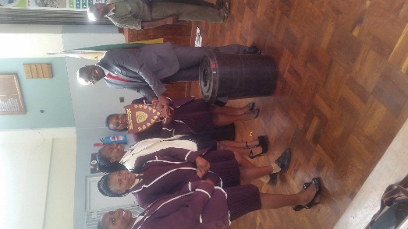 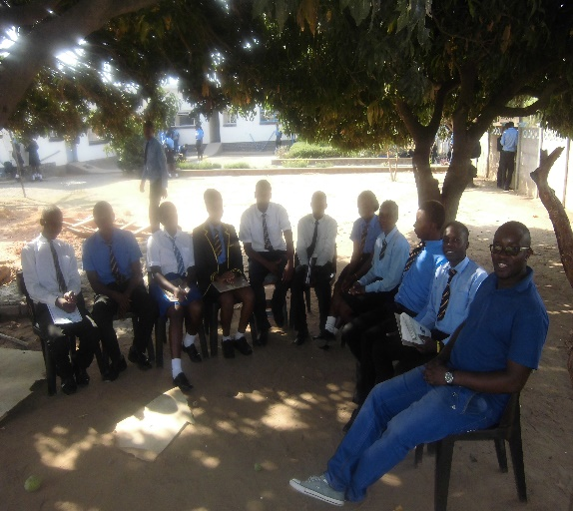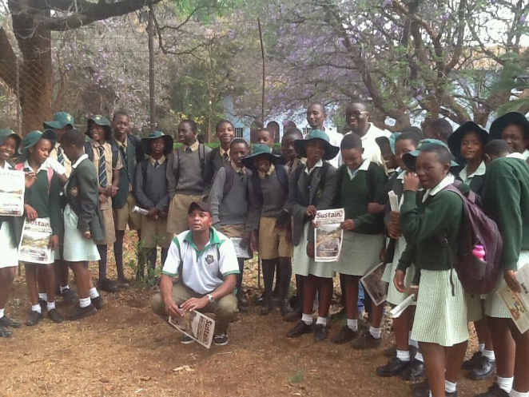 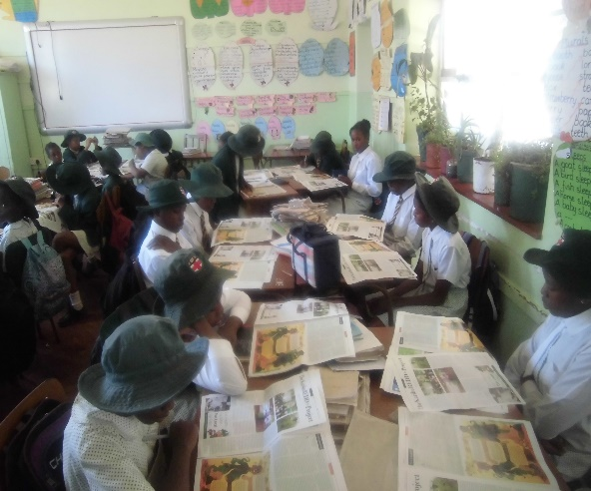

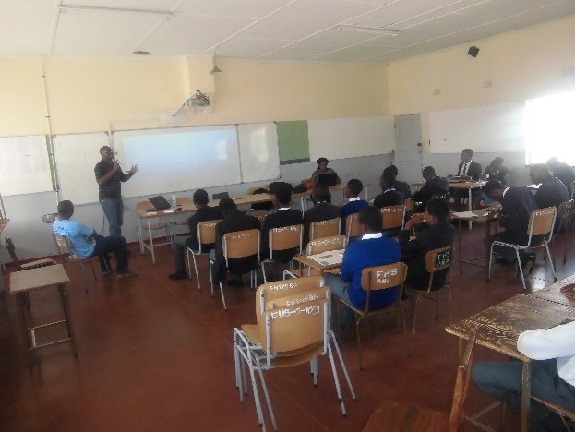 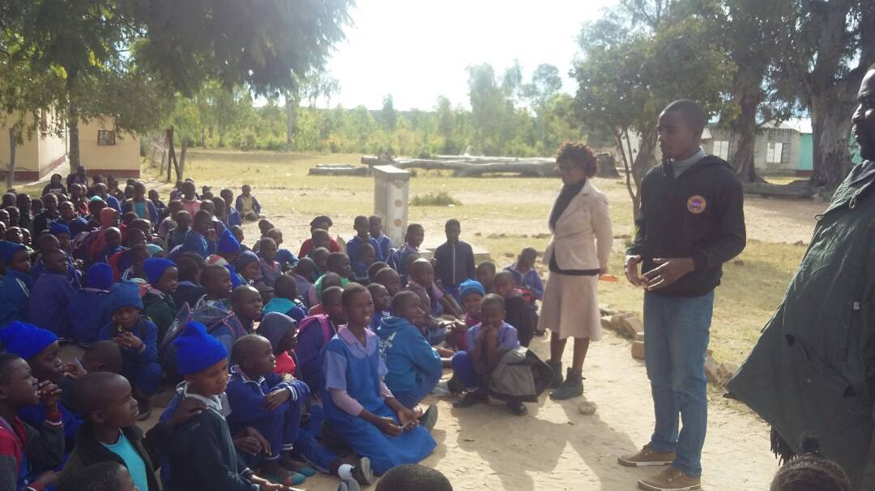

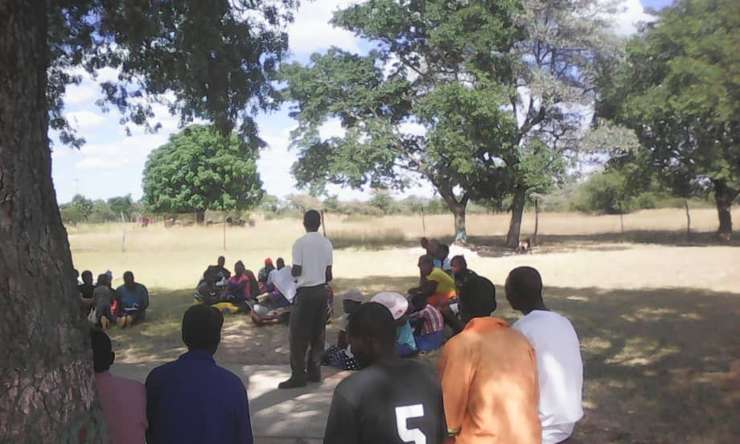 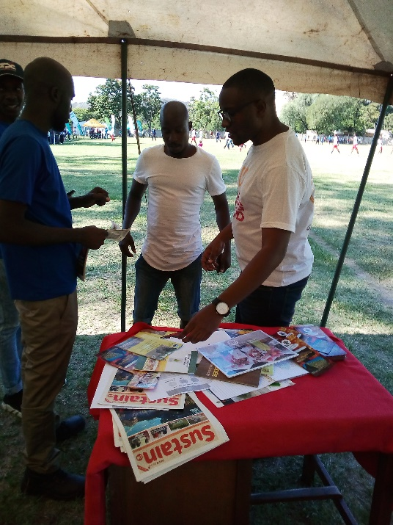

PROGRAMME: **RENEWABLE ENERGY AND WASTE MANAGEMENT**

PROJECT TITLE: **WASTE MANAGEMENT AND CLEAN UP CAMPAIGNS**

THEME: ***PUTTING VALUE IN WASTE***

AREA OF IMPLEMENTATION: **GWERU AND KWEKWE**

DURATION: **5 YEARS (IN IMPLEMETATION SINCE JUNE 2016)**

TARGET SECTORS**: BUSINESSES/COMPANIES AND COMMUNITIES**

This programme with aims to create a clean and safe environment for the residents of Gweru and Kwekwe and companies operating in and around the CBD’s. The theme of the programme shall be “Putting Value in Waste”. Central to the conduct of the programme shall be to create environmental entrepreneurs and improve the livelihoods of people in Gweru and Kwekwe through the collection of recyclable waste materials.

**Goals**

* Providing companies and communities with environmentally sound management of all forms of waste and significantly reduce its release to the land, air and water, in the process minimizing waste adverse impact on human health and the environment.
* Substantially reduce waste generation through prevention, reduction, recycling, reuse and recover.

**Outcomes and Milestones achieved**

* Collected and recycled 500 tonnes of cardboard box, 18 tonnes of plastic and 15 tonnes of pet bottles and 10 tonnes of cans
* Adoption of sustainable management of waste and efficient use of natural resources by companies and communities.
* Significant reduction in waste material disposed at illegal undesignated sites.
* Increased participation in waste management initiatives by companies and communities.
* Empowered environment entrepreneurs equipped with skills and knowledge in waste management.
* Improved livelihoods among residents of Gweru and Kwekwe through the collection and selling of recyclable waste material

Link: [www.sustainzim.org/putting-value-waste](http://www.sustainzim.org/putting-value-waste)

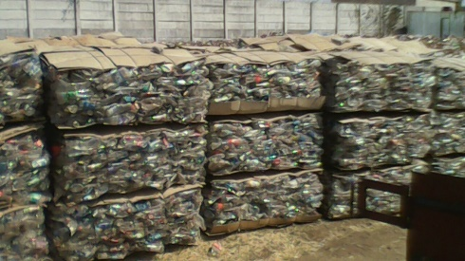 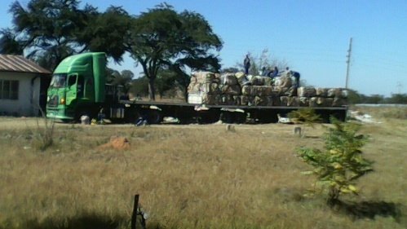

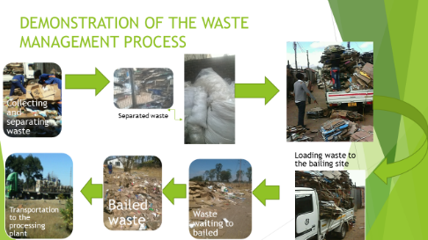

**PROGRAMME**: Tree Planting and Protection of Forest

**PROJECT TITLE**: Sustainable Forest Management

**THEME:** ‘Our Forest Our Future’

**AREA OF IMPLEMENTATION**: Midlands Province

**DURATION**: 5 Years (Implemented since November 2016)

**TARGET SECTORS**: Schools, Communities and Businesses

The theme for the programme is ‘Our Forest Our Future’. SOET recognises and values the environmental, social, cultural and economic contribution of trees to our communities. Effective Tree Planting activities and good Forestry Management play a critical role in reducing the impacts and effects of climate change. Therefore, against this background SOET is committed to managing forests across the country by promoting community stewardship and strategic practice to preserve, renew and enhance this essential resource. Central to the conduct of the programme is the creation of tree nurseries in several communities and schools across the Midlands Province. SOET strives to improve the livelihoods of people through sustainable forestry management. Promotion of agro-forestry in communities shall also likely boost the food security status of most people.

**Goals**

* Promoting the implementation of sustainable management of all types of forests, halting deforestation, restoring degraded forests and substantially increase afforestation and reforestation in Zimbabwe and beyond
* Improving livelihoods through sustainable agro-forestry initiatives

**Outcomes and Milestones reached**

* Established 15 community and school tree nurseries in the Midlands Province.
* 2600 trees planted in the Midlands Province
* 1200 bottles of marmalade made from lemon and orange trees planted in the tree nurseries sold
* Empowered communities alleviated from poverty through sustainable utilisation of forests
* Improved food security status in communities through adoption of agro-forestry initiatives.
* Increased understanding and knowledge about the importance of trees in communities across the Midlands Province.
* Adoption and practice of basic environment friendly practices by communities and businesses.

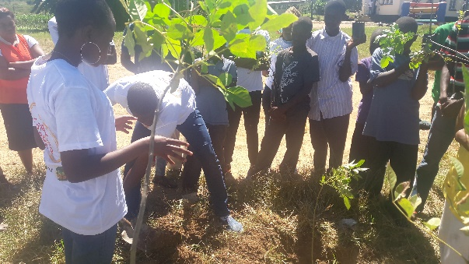 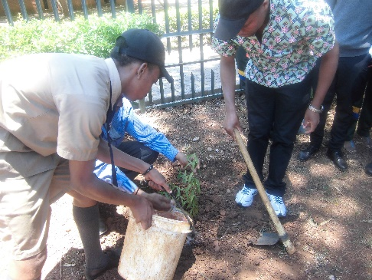

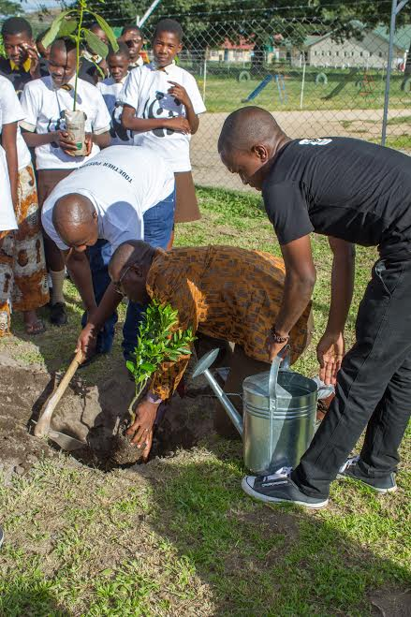 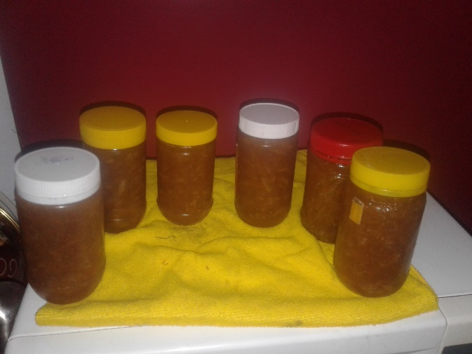

PROGRAMME: **FOOD SECURITY AND AGRICULTURE**

PROJECT TITLE: **WASTE MANAGEMENT AND CLEAN UP CAMPAIGNS**

AREA OF IMPLEMENTATION: **MIDLANDS PROVICE**

DURATION: **5 YEARS (IN IMPLEMETATION SINCE 2018)**

TARGET: **COMMUNITIES AND SCHOOLS**

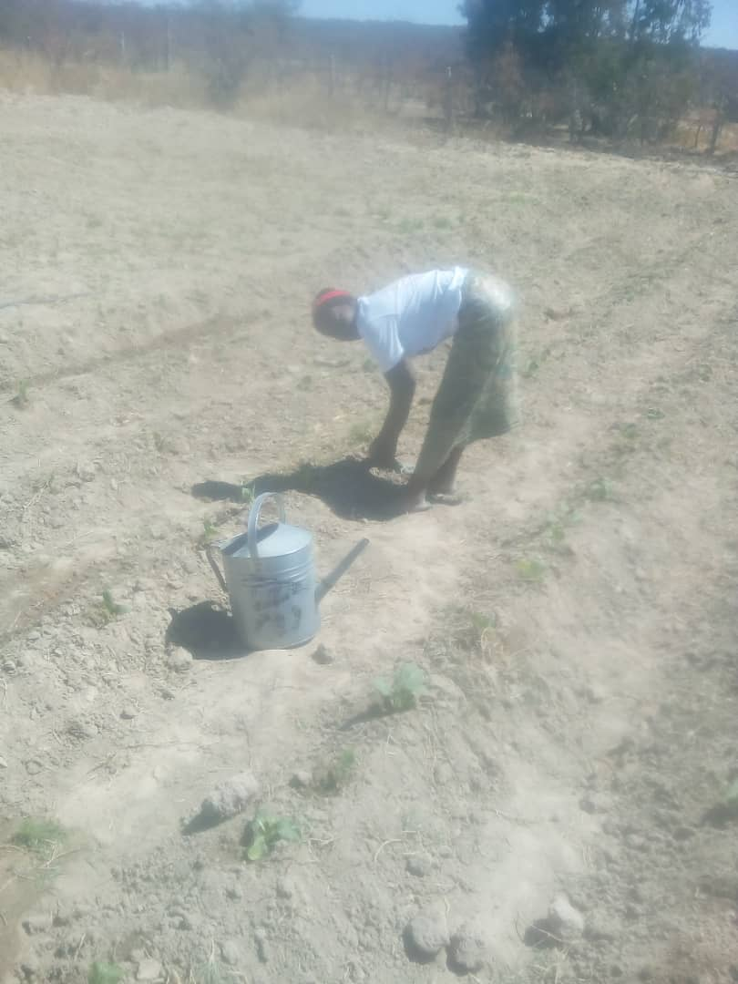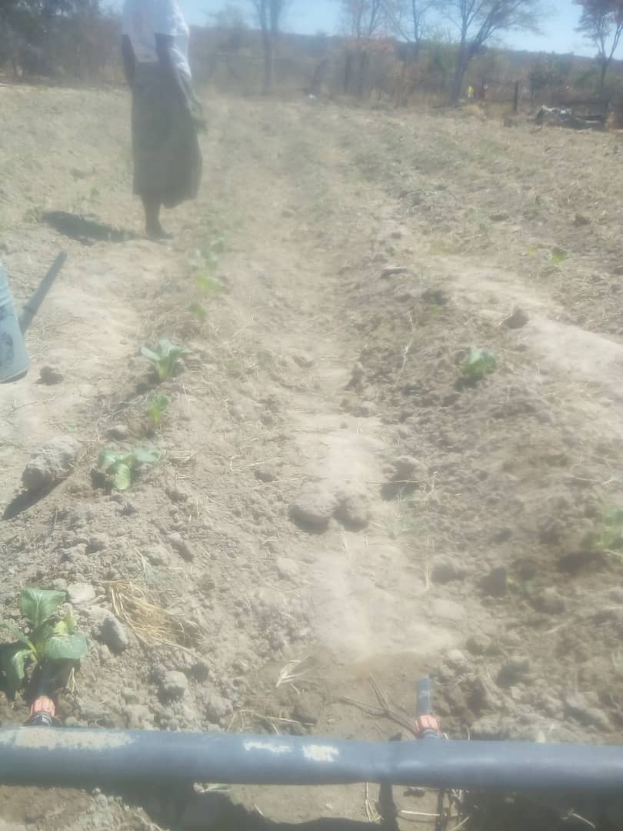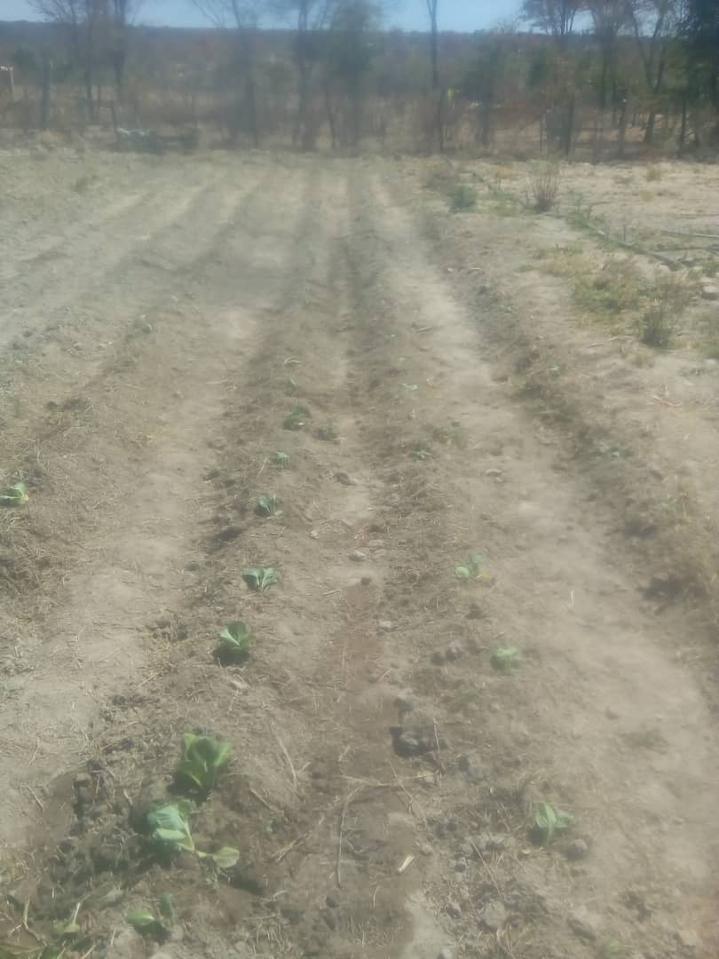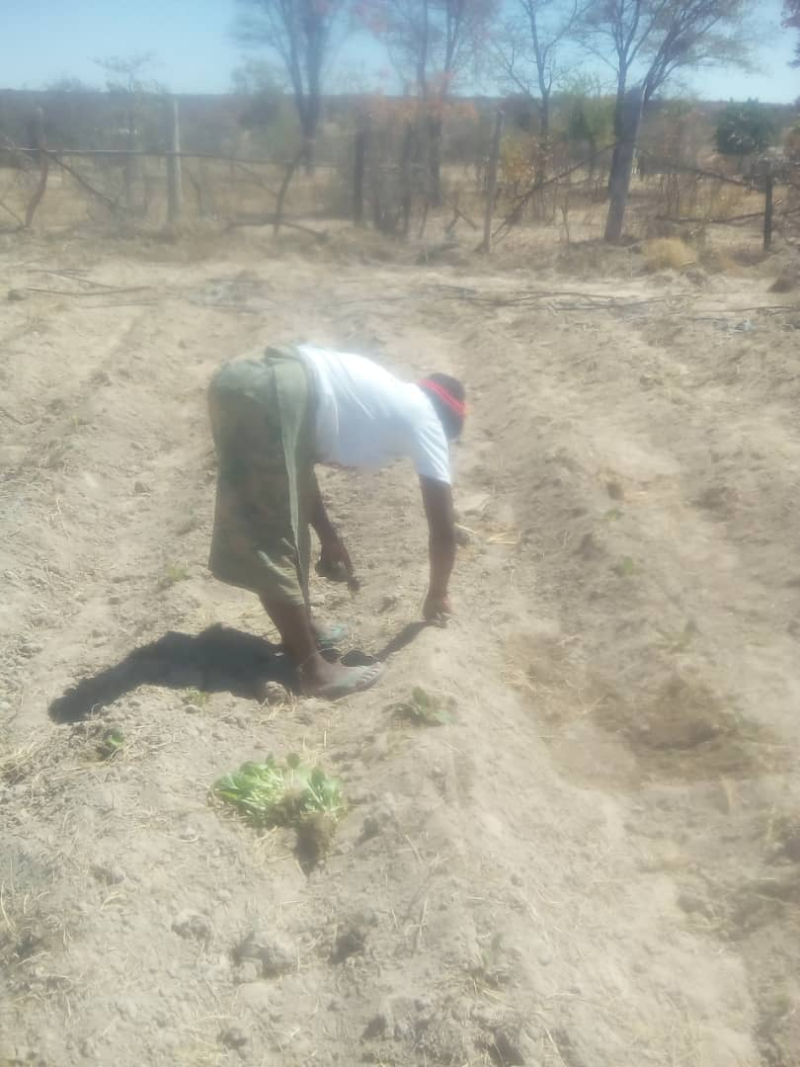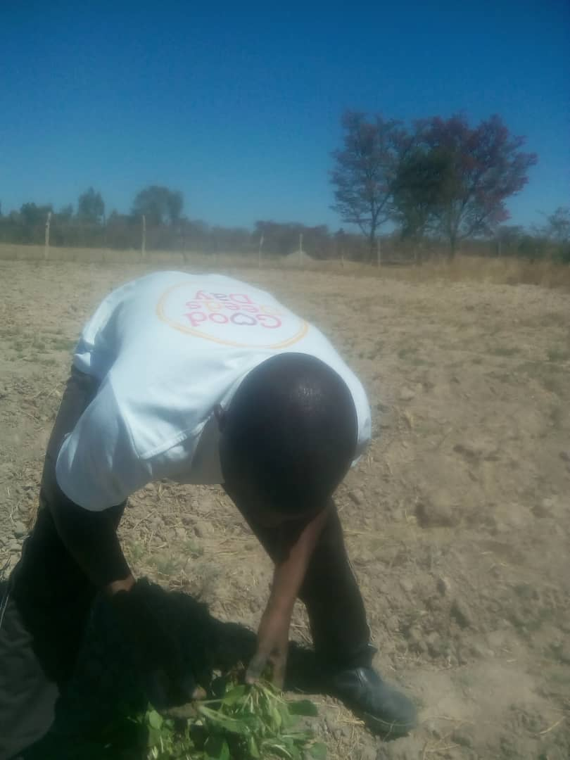

Cecil John Rhodes Primary Save Our Environment Trust Pupils exhibiting their agricultural products at the Zimbabwe 11th International Research Symposium. The above pictures show the pupils presenting their exhibitions to His Excellency President R.G Mugabe and his two Vice Presidents.